Global Superstore Dashboard Analysis

Total Revenue
SELECT
ROUND(SUM(Sales),0) AS Total_Revenue
FROM global_superstore;
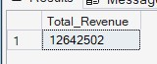
Total Orders
SELECT
COUNT(Order_ID) AS Total_Orders
FROM global_superstore;
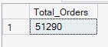
Total Profit
SELECT
ROUND(SUM(Profit),0) AS Total_Profit
FROM global_superstore;
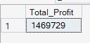
Total Units Sold
SELECT
SUM(Quantity) AS Units_Sold
FROM global_superstore;

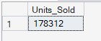

Profit Margin
SELECT
ROUND(SUM(Profit)/SUM(Sales),2) * 100 AS Profit_Margin
FROM global_superstore;
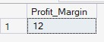
Revenue by Region
SELECT
Region,
ROUND(SUM(Sales),0) AS Revenue
FROM global_superstore
GROUP BY Region
ORDER BY Revenue DESC;
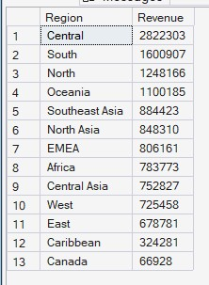
Top 5 Products
SELECT
TOP 5
Product_Name,
ROUND(SUM(Sales),0) AS Revenue
FROM global_superstore
GROUP BY Product_Name
ORDER BY Revenue DESC;
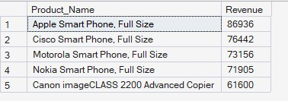
Monthly Revenue Trend
SELECT
Order_Year AS Year,
Order_Month AS Month,
ROUND(SUM(Sales),0)AS Revenue
FROM global_superstore
GROUP BY Order_Year, Order_Month
ORDER BY Year,Revenue DESC;
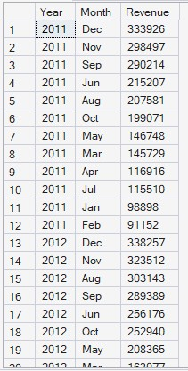
Loss Making Products
SELECT
Product_Name,
ROUND(SUM(Profit),0) AS Profit
FROM global_superstore
GROUP BY Product_Name
HAVING SUM(Profit) < 0
ORDER BY Profit;
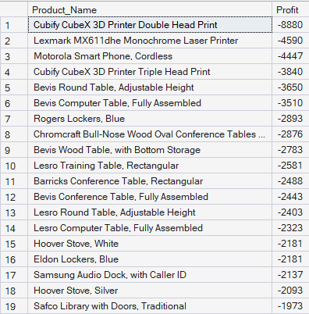
Running Total Revenue
SELECT
Order_Date,
ROUND(SUM(Sales),0) AS Daily_Sales,
ROUND(SUM(SUM(Sales)) OVER(ORDER BY Order_Date),0) AS Running_Revenue
FROM global_superstore
GROUP BY Order_Date
ORDER BY Order_Date;
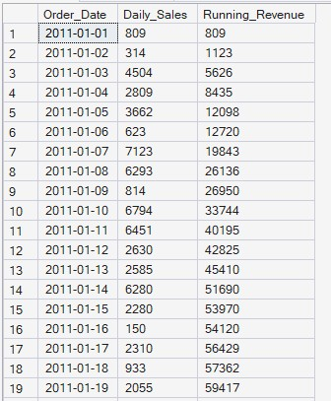
Rank Top Cities by Revenue
SELECT *
FROM (
SELECT
City,
ROUND(SUM(Sales),0) AS Revenue,
RANK() OVER(ORDER BY SUM(Sales) DESC) AS City_Rank
FROM global_superstore
GROUP BY City
) AS t
WHERE City_Rank <=10;
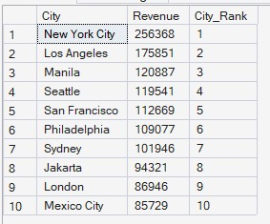
Region Wise Contribution %
SELECT
Region,
ROUND(SUM(Sales),0) AS Region_Revenue,
ROUND(SUM(Sales) * 100.0 / SUM(SUM(Sales)) Over(),2) AS Contribution_pct
FROM global_superstore
GROUP BY Region
ORDER BY Contribution_pct DESC;
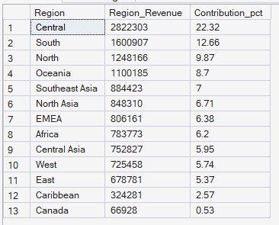
Monthly Sales Growth Using CTE
WITH Monthly_Sales AS
(
SELECT
YEAR(Order_Date) AS Year,
MONTH(Order_Date) AS Month,
ROUND(SUM(Sales),0) AS Revenue
FROM global_superstore
GROUP BY YEAR(Order_Date), MONTH(Order_Date)
)
SELECT *,
ROUND(Revenue - LAG(Revenue) OVER(ORDER BY Year,Month),0) AS Sales_Growth
FROM Monthly_Sales;
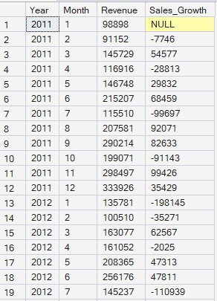
Top Customer in Each Region
WITH Cust_Sales AS
(
SELECT
Region,
Customer_ID,
ROUND(SUM(Sales),0) AS Revenue
FROM global_superstore
GROUP BY Region, Customer_ID
)
SELECT *
FROM
(
SELECT *,
ROW_NUMBER() OVER(PARTITION BY Region ORDER BY Revenue DESC) AS rn
FROM Cust_Sales
) AS t
WHERE rn = 1;
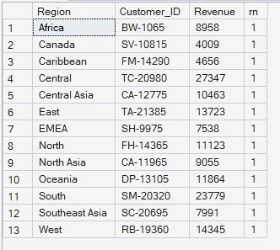
Products Performing Above Average
SELECT
Product_Name,
ROUND(SUM(Sales),0) AS Revenue
FROM global_superstore
GROUP BY Product_Name
HAVING SUM(Sales) >
(
SELECT AVG(Product_Revenue)
FROM(
SELECT
SUM(Sales) AS Product_Revenue
FROM global_superstore
GROUP BY Product_Name
) t
);
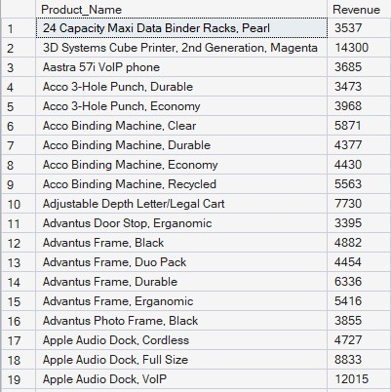
Repeat Customer Detection
WITH Cust_Orders AS
(
SELECT
Customer_ID,
COUNT(DISTINCT Order_ID) AS Total_Orders
FROM global_superstore
GROUP BY Customer_ID
)
SELECT *
FROM Cust_Orders
WHERE Total_Orders > 1
ORDER BY Total_Orders DESC;
